**PETER CANOVA MEDIA KIT**

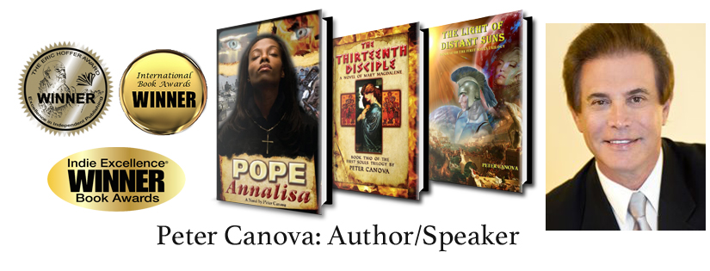

**Brand:** *Quantum Spirituality* as promoted by Peter Canova in books and public speaking.

**Central Message:** Quantum spirituality is the merger of ancient mystical wisdom and science with a primary focus on the nature of consciousness as being the foundation of reality. This squarely opposes the views of dogmatic religion and materialistic science, both of which give false pictures of reality and the creation.

Materialistic science holds that matter is primary and conscious life is merely the by-product of electro-chemical functions of the brain. Dogmatic religion proposes an external God that waved a hand and created conscious life from the dust of the earth.

Advanced quantum theory and ancient (particularly Gnostic) sacred wisdom tell us that matter descended from a universal consciousness and humans are not separate creations but direct projections of that infinite consciousness expressed in physical form.

**Peter Canova Bio:** Peter has thirty-five years of voluminous research behind him in quantum physics, and both mainstream and alternative religious/spiritual traditions with a particular interest in early Christianity.  He is a leading expert on Gnostic and other ancient wisdom traditions.

Peter is an author, public speaker and TV show host dealing with such topics as the source of consciousness, parallels between Gnostic mysticism and quantum physics, the Sacred Feminine, Mary Magdalene and the lost women of the Bible, and the secret teachings of Jesus. His skills helped him break down these often complex spiritual and scientific themes into simple and entertaining fiction. Both his non-fictional and fictional writings are a combination of this research and information channeled in his own meditations.

Coming from a successful business background, Peter experienced vivid psychic phenomena such as telepathy, remote viewing, psychic healing, and he displayed abilities as an accurate medical intuitive. Spurred by these experiences, he spent much of his life seeking to understand the forces that affect humanity at an unseen level.

Peter shares what he has learned through public speaking as well as non-fictional and fictional writings. His **First Souls Trilogy**, a series of spiritual thrillers have on an incredible total of **25 national and international literary awards** including Nautilus, Writer’s Digest and most recently the Indie Excellence Award for best book series. His newest non-fiction work is the forthcoming **Quantum Spirituality**.

**Partial list of Credentials and Experience:**

**Leadoff Speaker** Global Alliance for Transformational Entertainment Saban Theater Los Angeles (Jim Carey, Edward James Olmos, Barbara Marks Hubbard, Eckhart Tolle et al.)

**Keynote Speaker** Unity Church National Convention

**Keynote Speaker** Centers for Spiritual Living National Convention

**Speaker/ Panelist** Conscious Living Expos LA, San Francisco (4x)

**Gaia TV** interview guest

**Spiritual Master International TV** interview guest

**Canadian TV** interview guest

**Coast to Coast with George Noory** interview guest (3x in one year)

**Three dozen radio interviews** available on website

**Comments on some of Peter’s books:**

”Pope Annalisa is an incredible read. It’s a great novel with a spiritual bent that doesn’t overwhelm. It reads better than The DaVinci Code or CelestineProphecy – more like The Color Purple for the Soul.”**— John Kremer, author of 1001 Ways to Market Your Book, speaker, and book marketing expert**

All I can say is WOW! What a great read**! -- from a judge at Writer’s Digest Awards**

“A unique thriller that's bound to be a classic . . . --- well told and powerful and I highly recommend it.”-- **Susanna K. Hutcheson, professional copywriter, feature writer, internet reviewer**

A Brilliant Visionary Novel Destined to Become a Classic, Peter Canova's debut novel has undoubtedly become one of my absolute favourite novels. Well done, Peter!! **Kiernan Antares, Talk Radio Host**

“Pope Annalisa is one of the most powerfully written novels I have read in a long time. .”— **Donna Seebo, award winning author, radio and TV personality**

**Peter Canova comments about his work in a 2012 Huffington Post interview --** “No work can be personally transformative unless it engages both the heart and the mind of the viewer. To be touched intellectually is to be affected; to be touched emotionally is to be moved. To be touched by both is to be raised to a new perception of being.”

**For Immediate Release:**

**First Souls Trilogy Wins Grand Prize for Best Series**

**Los Angeles, May 15, 2019** – Trimountaine Publishing is pleased to announce that Peter Canova’s FIRST SOULS TRILOGY – ***Pope Annalisa***, ***The Thirteenth Disciple***, and ***The Light of the Distant Suns***, has won The Indie Next Generation Award for Best Book Series.

This is the twenty fifth award bestowed on the trilogy and perhaps the most significant one, because it recognizes Canova’s complete body of work, not just a single novel, and because it won in a category open to all genres, making the competition particularly fierce.

The award is further distinguished by the significant challenges posed in conveying a story told in three separate genres. The novels, which Canova refers to as spiritual thrillers, concern the first fall of spirit consciousness into material existence. Written in reverse order, the series uniquely spans three different genres – contemporary fiction, historical fiction, and science fiction-high fantasy—told through the incarnations of cardinal souls whose lives reoccur at different critical evolutionary crossroads of human history.

Mr. Canova’s visionary trilogy combines elements of ancient spirituality and quantum physics told in the style of page-turning thrillers that both entertain and educate. The trilogy is a spellbinding speculation on human origins and a grand epic about the titanic struggle of the human spirit to overcome its limitations and regain its lost station in a higher plane of existence.

**Contact:** Steve Allen Media

Steve Allen

661.255.8283

Media@SteveAllen.net

**SUGGESTED TOPICS ON WHICH PETER CAN SPEAK**

1. Sacred Feminine/Mary Magdalene—lost Judeo/Christian feminine spirituality
2. Art as the function of universal spiritual truth
3. The Universal Spiritual Tradition underlying all major religions
4. Gnosticism—the repressed Christian mystical tradition
5. The intersections of myth and science
6. The Third Way—ancient spiritual traditions and quantum physics superseding religion and traditional science
7. Jungian Psychology and ancient Gnosticism
8. The lost Genesis story
9. Women and the early Church—how women were written out of the Bible
10. Kabbalah, Sufism, and Gnosticism—the union of Judaism, Christianity and Islam
11. Was there a secret teaching of Jesus and other prophets?